Renju lesson on January 24, 2002

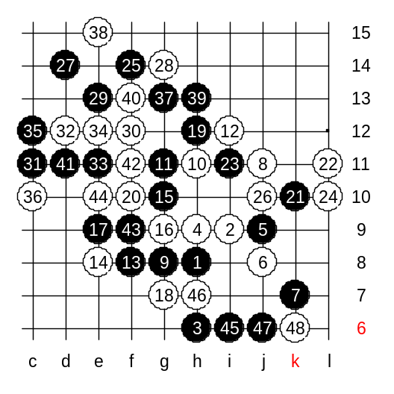
Hello everyone! Welcome to Online Renju Class. We continue with i10 today. Today we will check the other 5th move. Move 5-j9 was so popular in the past. I have played tens of games in this variant before. It gives black advantage. In fact, this 5th move brought me the World Champion title in the first time. In 1993, I used this 5th move in the last round of the WC, against Nikonov. Nara had half point more, so it was necessary that Nara would lose his last game to Reims and I would win Nikonov. At that time 5-i7 was seldom used. So I played 5-j9. The traditional continuation was 6-j8. Other 6th moves all lose, I think. And even after this 6th move, black is still good. Which are the possible 7th moves? Indeed, both h10 and k7 are correct. Lets study k7 first. I like k7 for its exciting continuations. Lots of beautiful analyses have been made there in the past. All begins from simple concept: Since black played to the lower side, and it is very powerful now, white cannot just go and defend there. Therefore white must keep up tempo and be active in upper side. If white attacks well, then it forces black to waste lower side material for defense. In the long term it will balance lower and upper side. Let’s see how it happens. There are 12 moves on the board now. White is very active. Black cannot continue with passive defense anymore. Therefore black has to waste lower side material now. Note that the sequence is important here. White plays actively, pushing 3x3 with L10. Is black in danger now? Or is it white who is in danger? :) I think black will try to attack a bit. Who can explain f14?? After f14 white is forced to play j10, otherwise black VCT on the right side. By the 27th move the situation is totally opposite from beginning. Now white is “loaded” and black is forced to keep attacking in order to stay alive. The following moves are all forced. One smallest mistake will give black win immediately. Whereas black must keep in mind that VCF threat must be maintained at all times. Otherwise white will counter-attack on the right side. As far as I know, there are two possible blocks after 35th move. The c13 is not among them. :) Move c10 is one of the possible blocks. Another is a11. Today we will check c10 closely. Black will first balance upper side before going to lower side. Black attack becomes exhausted by 48th move.
As you see, although black attack was scary, white was able to defend with correct moves. Many people used f14 in order to get easy wins. But after a while, people also learned white defense and f14 faded soon. People began to use careful 25th move instead.
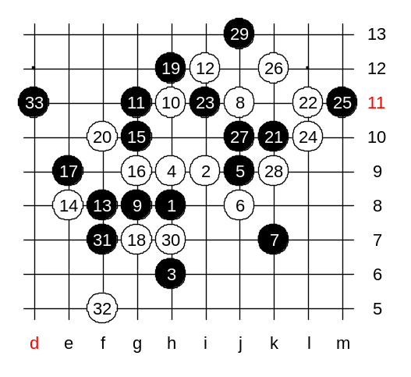
Black uses passive style instead. 25-m11. Move j10 – active block of white’s 4x3. There are two 29th moves – j13, L12. We play j13. Well, the following moves are not for either sides anyway. Therefore we end the variant here. The outcome is about equal. Sometimes black won the games in this variant, sometimes white did. One important thing though. Black has two areas – left upper and lower. Therefore white must block carefully. If field h7 remains empty, then black wins in upper side with d11 if black can play there first. Therefore it is important to block h7 field. So, maybe the next steps would be: 30-h7, 31-f7, 32-f5. Note that black will try d11 anyway in upper side later. But now black does not win there because of closed h7. Anyway black attack is dangerous above and many players win due to white mistake there.

